
ECE Department
Information Theory
ECE457
IT Project Report
presented by
عبدالرحمن علمي زكي الطوانسي
معاذ سعيد حسن مرسي

Import Image: 2
Calculate probabilities of each unique symbol: 3
Testing Example: 3
Sum all probrobilities to check that (Total probs = 1): 3
sorting and combing probs: 4
Sort all tree elements and applying Huffman Tree : 4
plot Huffman Tree: 4
Assign 0 and 1 to symbols in Huffman Tree: 5
Extract all codewords from Huffman Tree: 6
Extract the codewords for the probs: 6
Mapping the image (convert pixels to bits): 7
Decoding the encoded image (convert bits to pixels) 7
the sizes of the input image and the output one from source coding: 8
compression ratio of the coded image: 8
The End 8
clc;
clear all;
close all;

Import Image:
%RGB = imread('finallydidit.png'); % for any random image
%imshow(RGB)
%RGB = rgb2gray(RGB);
%figure
%imshow(RGB)
RGB = imread('256_shades_of_grey.png'); % this image has equal probs
imshow(RGB)
title('input Gray image');
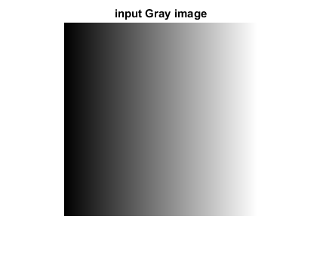

Calculate probabilities of each unique symbol:
sym=unique(RGB);
sizergb(1:2)=size(RGB);
for s=1:length(sym)
i=find(RGB==sym(s));
prob_dist(s)=length(i)/(sizergb(1).*sizergb(2));
end

Testing Example:
%sym =[1 2 3 4 5];
%prob_dist =[0.2 0.2 0.2 0.2 0.2];
%sym =1:length(prob_dist);

Sum all probrobilities to check that (Total probs = 1):
total = sum(prob_dist);
display(total)
total =
1
for i = 1:length(sym)
sorted_sym{i} = sym(i);
end
init_sym = sorted_sym;
init_prob = prob_dist;

sorting and combing probs:
sorted_prob = prob_dist;
count = 1;
while (length(sorted_prob) > 1)
% Sort probs
[sorted_prob,indeces] = sort(sorted_prob,'ascend');
% Sort symbol based on indeces
sorted_sym = sorted_sym(indeces);
% Create new symbol
new_node = strcat(sorted_sym(2),sorted_sym(1));
new_prob = sum(sorted_prob(1:2));
% Dequeue used symbols from "old" queue
sorted_sym = sorted_sym(3:length(sorted_sym));
sorted_prob = sorted_prob(3:length(sorted_prob));
% Add new symbol back to "old" queue
sorted_sym = [sorted_sym, new_node];
sorted_prob = [sorted_prob, new_prob];
% Add new symbol to "new" queue
newq_sym(count) = new_node;
newq_prob(count) = new_prob;
count = count + 1;
end

Sort all tree elements and applying Huffman Tree :
tree = [newq_sym,init_sym];
tree_prob = [newq_prob, init_prob];
[sorted_tree_prob,indeces] = sort(tree_prob,'descend');
sorted_tree = tree(indeces);
parent(1) = 0;
for i = 2:length(sorted_tree)
% Extract symbol
me = sorted_tree{i};
% Find parent's symbol (search until shortest match is found)
count = 1;
parent_maybe = sorted_tree{i-count};
different = strfind(parent_maybe,me);
while (isempty(different))
count = count + 1;
parent_maybe = sorted_tree{i-count};
different = strfind(parent_maybe,me);
end
parent(i) = i - count;
end

plot Huffman Tree:
figure
treeplot(parent);
%title(strcat('Huffman Coding Tree - "',sym,'"'));
[xs,ys,h,s] = treelayout(parent);
text(xs,ys,sorted_tree);
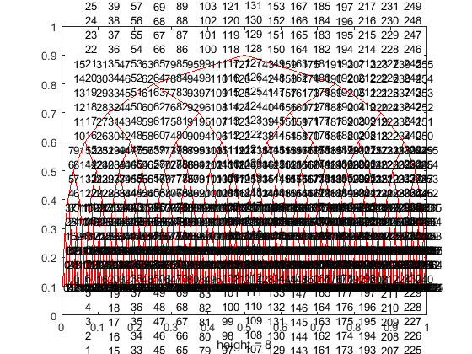

Assign 0 and 1 to symbols in Huffman Tree:
for i = 2:length(sorted_tree)
% Get my coordinate
my_x = xs(i);
my_y = ys(i);
% Get parent coordinate
parent_x = xs(parent(i));
parent_y = ys(parent(i));
% Calculate weight coordinate (midpoint)
mid_x = (my_x + parent_x)/2;
mid_y = (my_y + parent_y)/2;
% Calculate weight (positive slope = 0, negative = 1)
slope = (parent_y - my_y)/(parent_x - my_x);
if (slope < 0)
weight(i) = 1; %assign 1
else
weight(i) = 0; %assign 0
end
text(mid_x,mid_y,num2str(weight(i)));
end
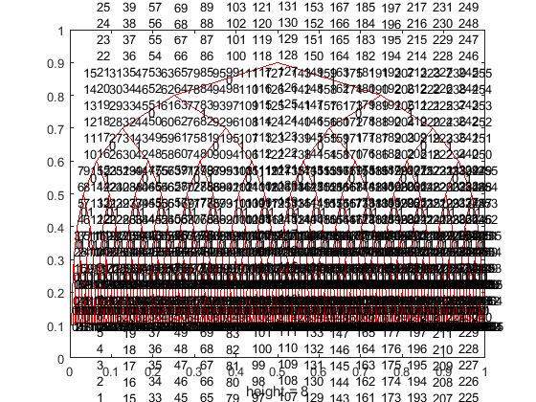

Extract all codewords from Huffman Tree:
for i = 1:length(sorted_tree)
code{i} = '';
index = i;
p = parent(index);
while(p ~= 0)
% Turn weight into code [bits(0,1) to string]
w = num2str(weight(index));
% Concatenate code symbol
code{i} = strcat(w,code{i});
% Continue towards root
index = parent(index);
p = parent(index);
end
end
allcodeword = [sorted_tree', code'];

Extract the codewords for the probs:
for k=1:length(init_sym)
for kk=1:length(allcodeword)
if (length(allcodeword{kk}) == length(init_sym{k})...
&& allcodeword{kk}==init_sym{k})
codeword{k}=allcodeword{kk,2};
end
end
end
sym_codeword=[init_sym',codeword'];

Mapping the image (convert pixels to bits):
for c=1:length(sym)
for cc=1:sizergb(1)
for ccc=1:sizergb(2)
if (sym_codeword{c,1}==RGB(cc,ccc))
rgb_encoded{cc,ccc}=sym_codeword{c,2};
end
end
end
end

Decoding the encoded image (convert bits to pixels)
for c=1:length(sym)
for cc=1:sizergb(1)
for ccc=1:sizergb(2)
if (length(sym_codeword{c,2}) == length(rgb_encoded{cc,ccc}))
if (sym_codeword{c,2} == rgb_encoded{cc,ccc})
rgb_decoded{cc,ccc}=sym_codeword{c,1};
end
end
end
end
end
RGB_decoded=cell2mat(rgb_decoded);
imwrite(RGB_decoded,'test.png')
Output_RGB = imread('test.png');
imshow(Output_RGB)
title('Output Gray image');
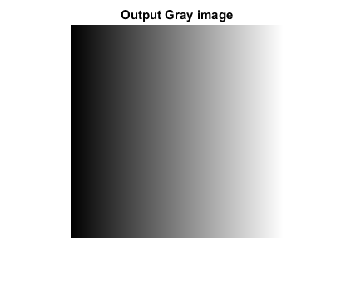

the sizes of the input image and the output one from source coding:
size_of_image=(sizergb(1)*sizergb(1)*8);
display(size_of_image)
encodedword_to_char=strjoin(rgb_encoded);
bits_of_encodedword=strrep(encodedword_to_char,' ','');
size_of_encoded_image=length(bits_of_encodedword);
display(size_of_encoded_image)
size_of_image =
524288
size_of_encoded_image =
524288

compression ratio of the coded image:
compression_ratio=(size_of_encoded_image)./(size_of_image);
display(compression_ratio)
compression_ratio =
1

The End
Published with MATLAB® R2016a

